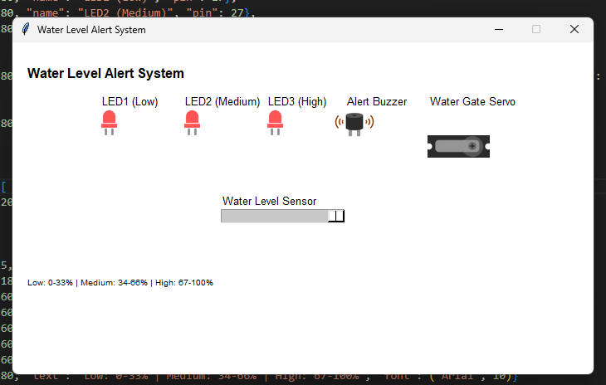

water_alert.py
from gpiozero import Servo, MCP3008, Button, LED, Buzzer
from time import sleep
import signal

print("Water Level Alert System is running...")

led_low = LED(17)
led_medium = LED(27)
led_high = LED(22)
servo = Servo(24)
buzzer = Buzzer(25)
water_sensor = MCP3008(0)

def main():
print("System active. Press Ctrl+C to exit.")

while True:
water_level = water_sensor.value
print(f"Water level: {water_level:.2f} ({int(water_level * 100)}%)")

# (Low) (0-33%)
if water_level >= 0:
led_low.on()
else:
led_low.off()

# Medium (34-66%)
if water_level > 0.33:
led_medium.on()
else:
led_medium.off()

# High (67-100%)
if water_level > 0.66:
led_high.on()
buzzer.on()
else:
led_high.off()
buzzer.off()

servo_position = (2 * water_level) - 1
servo.value = servo_position

sleep(0.5)

if __name__ == "__main__":
main()

water_alert_simulation.py
from tkgpio import TkCircuit

configuration = {
"name": "Water Level Alert System",
"width": 700,
"height": 400,

"leds": [
{"x": 105, "y": 80, "name": "LED1 (Low)", "pin": 17},
{"x": 205, "y": 80, "name": "LED2 (Medium)", "pin": 27},
{"x": 305, "y": 80, "name": "LED3 (High)", "pin": 22}
],
"servos": [
{"x": 500, "y": 80, "name": "Water Gate Servo", "pin": 24, "min_angle": -90, "max_angle": 90, "initial_angle": 0}
],
"buzzers": [
{"x": 400, "y": 80, "name": "Alert Buzzer", "pin": 25}
],
"adc": {
"mcp_chip": 3008,
"potentiometers": [
{"x": 250, "y": 200, "name": "Water Level Sensor", "channel": 0}
]
},
"labels": [
{"x": 15, "y": 25, "text": "Water Level Alert System", "font": ("Arial", 16, "bold")},
{"x": 250, "y": 180, "text": "Water Level Sensor", "font": ("Arial", 10)},
{"x": 105, "y": 60, "text": "Low", "font": ("Arial", 10)},
{"x": 205, "y": 60, "text": "Medium", "font": ("Arial", 10)},
{"x": 305, "y": 60, "text": "High", "font": ("Arial", 10)},
{"x": 500, "y": 60, "text": "Water Gate", "font": ("Arial", 10)},
{"x": 400, "y": 60, "text": "Buzzer", "font": ("Arial", 10)},
{"x": 15, "y": 280, "text": "Low: 0-33% | Medium: 34-66% | High: 67-100%", "font": ("Arial", 10)}
]
}

circuit = TkCircuit(configuration)

@circuit.run
def main():
import water_alert

water_alert.main()

